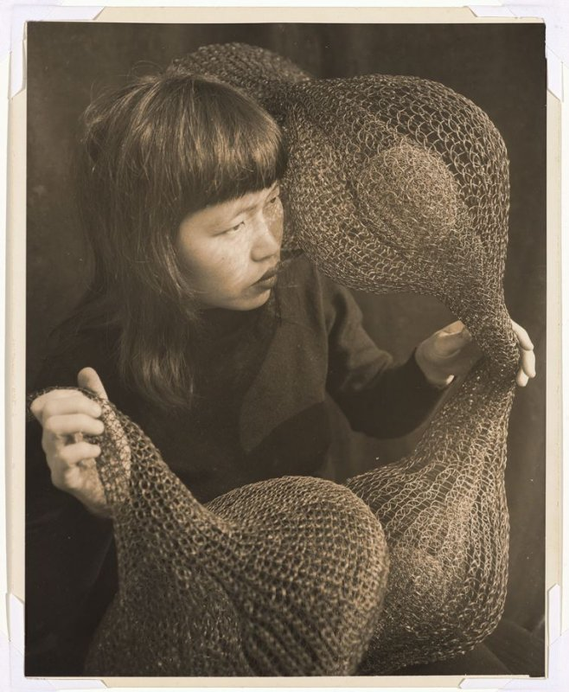
Ruth Asawa
(1924–2013)
“A child can learn something about color, about design, and about observing objects in nature. If you do that, you grow into a greater awareness of things around you. Art will make people better, more highly skilled in thinking and improving whatever business one goes into, or whatever occupation. It makes a person broader.” —Ruth Asawa

Teacher Packet
© 2020

Table of Contents
Biography: Ruth Asawa 3
Lesson 1: Wire Sculpture Explorations (Grades K–12) 5
Lesson 2: Craft and Design vs. Fine Art, A Gendered Lens (Grade 5 and above) 8
Lesson 3: Considering Public Art and Civic Participation (Grade 5 and above) 11
Lesson 4: The Japanese American Incarceration Experience (Grade 8 and above) 15
Appendix A 22
Resources 23

Cover image: Untitled (Ruth Asawa holding a looped wire sculpture), 1952, by Imogen Cunningham (American, 1883–1976). Sepia-toned gelatin silver print. FAMSF, Gift of Ruth Asawa and Albert Lanier, 2006.114.1.

Biography: Ruth Asawa
Ruth Aiko Asawa Lanier (1926–2013) was a prominent sculptor, public artist, and tireless arts education advocate. Born into a large family with Japanese parents, Asawa’s early life was spent on farms. In 1942, with the signing of Executive Order 9066, the Asawas were forced to leave their family farm in California. While incarcerated at the Rowher Relocation Center in Arkansas, Asawa graduated high school, excelling in her art classes. With the help of the Japanese American Student Relocation Council, she was accepted to Milwaukee State Teachers College and was permitted to leave the incarceration camp to pursue her education. Discrimination in the program caused Asawa to transfer to Black Mountain College in North Carolina. There she met her future husband, Albert Lanier, and influential mentors like Buckminster Fuller and Josef Albers. In the 1950s, the couple moved to San Francisco and started a family. As their family expanded to include six children, Asawa worked in her home studio, slowly gaining recognition for her wire sculptures. She was welcomed into a vibrant Bay Area arts community and with the prompting of her close friend Imogen Cunningham began creating under her maiden name, Asawa. In 1960, the de Young Museum exhibited a solo show on Asawa’s sculptures and drawings. Beyond her artistic achievements, Ruth Asawa was a committed arts advocate, serving on the San Francisco Arts Commission, the California Arts Council, and the National Crafts Planning Project of the National Endowment for the Arts. This commitment to the arts was both national and local, as she co-founded the Alvarado School Arts Workshop and was deeply involved with San Francisco’s School of the Arts, which was eventually renamed in her honor. A true artistic pioneer, Asawa challenged conceptions of what it meant to be an Asian American, a mother, a fine artist, and a public arts advocate.

Lesson Plans/Activities
In the following teacher packet, students and teachers will have the ability to investigate the following prompts :
- Ruth Asawa Inspired Sculpture (Grades K-12)
- Craft and Design vs. Fine Art, A Gendered Lens (Grade 7 and above)
- Considering Public Art and Civic Engagement (Grade 7 and Above)
- The Japanese American Incarceration Experience: Loyalty and Civil Rights

Grade Levels: The following lesson plans are designed for 6th grade and above with the art activity accessible for K-12 students.

Keywords/Topics of Study: Ruth Asawa, Sculptors, Japanese American Artists, Japanese American Experience, Women Artists of Color, Craft and Design, Public Arts, Arts Education Activism, Civil Rights, Japanese Incarceration Experience, Public Arts Activism, Civic Participation

Video Biographies of Ruth Asawa
https://www.youtube.com/watch?v=T79DObA_3Dg
https://www.interiordesign.net/articles/15313-the-wire-sculpture-of-ruth-asawa/

Visual Archives of Ruth Asawa’s Art
Ruth Asawa website: https://ruthasawa.com/art/

Institutional Collections for Public Viewing
Ruth Asawa website: https://ruthasawa.com/resources/collections/

Bay Area institutions that include Ruth Asawa’s work in their permanent collections:

Sculpture and works on paper
M.H. de Young Memorial Museum
50 Hagiwara Tea Garden Drive
Golden Gate Park
San Francisco, California

Sculpture and works on paper
Oakland Museum of California
1000 Oak Street
Oakland, California

Sculpture
San Jose Museum of Art
110 South Market Street
San Jose, California

Lesson 1: Wire Sculpture Explorations (Grades K–12)
Objective: Students will critically examine Asawa’s sculpture work and create their own works of art in her style using principles of geometry and 3-D shapes.
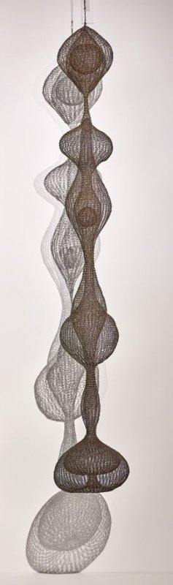
Introduction: Ruth Asawa was best known for her abstract, biomorphic sculptures. Using looped wire mesh, she wove large scale forms that combined architectural elements with craft and design. These forms would become her signature art, eventually changing the genre of sculpture. Using geometric figures and abstract shapes, her installations redefine fluidity and space.
Common Core Standards (California):
Grade 1 2.0 CREATIVE EXPRESSION
2.1: Use texture in two‐dimensional and three‐dimensional works of art.
2.3: Demonstrate beginning skill in the manipulation and use of sculptural materials (clay, paper, and papier-mâché) to create form and texture in works of art.

Grade 3 4.0 AESTHETIC VALUING
4.1: Compare and contrast selected works of art and describe them, using appropriate art vocabulary.

Visual Arts Grade 7 2.0 CREATIVE EXPRESSION
2.1: Develop increasing skill in the use of at least three different media. 2.3: Develop skill in using mixed media while guided by a selected principle of design.
Grade 8 3.0 HISTORICAL & CULTURAL CONTEXT
3.3: Identify major works of art created by women and describe the impact of those works on society at that time.

Image: Untitled, approx. 1955, by Ruth Asawa (American, 1926–2013). Copper and brass wire. de Young Museum, Gift of Jacqueline Hoefer, 2006.76.1. © Estate of Ruth Asawa.

Materials
Examples of Asawa’s sculptures
Plastic coated craft wire, pipe cleaners, or sculpting wire
Various colored or textured paper cut into strips
Yarn or thick thread
Corkscrews
Examples of geometric shapes (Appendix A)
Optional:
cardboard bases
glue guns
beads or button for decorating

Vocabulary
Sculpture
the art of carving, modeling, welding, or otherwise producing figurative or abstract works of art in three dimensions, as in relief, intaglio, or in the round.
Source : Dictionary.com
2-D, or two-dimensional
simply means that the shape is flat. We can draw 2-D shapes on paper.
3-D or three-dimensional
the shape is a solid shape. It has three dimensions, that is, length, width and depth.
Source: Openlearn https://www.open.edu/openlearn/ocw/mod/oucontent/view.php?id=84739&section=1.3
Positive Space
refers to the subject or areas of interest in an artwork, such as a person's face or figure in a portrait, the objects in a still life painting, or the trees in a landscape painting.
Negative Space
negative space is the background or the area that surrounds the subject of the work.
Source: https://whitney.org/education/forteachers/activities/115

Procedure
- Introduce students to Asawa by discussing her biography or showing a biographical video from the video archives above. Use the visual art archives to project examples of her work for the class to view.
- Define sculpture, 2-D, 3-D, Positive Space, Negative Space, and any math terms that are appropriate for your students. Examples include geometric shape names, “polyhedron,” “face,” “edge,” “prism,” etc.

Art Project
- Give instructions to the class—students will create geometric shapes using the materials provided and then connect the shapes into a larger sculpture.
  - Decide on the number of shapes students will create based on class time and skill levels. Two to four shapes is an appropriate range unless this project will span multiple class periods.
- Demonstrate techniques for manipulating the wire or pipe cleaners. Asawa’s personal technique was to wrap wire over a wooden dowel and remove the dowel before flattening the loops.
  - Ask students to consider different ways to bind their materials together.
  - Project examples of different 3-D shapes for students to model their sculptures after.
- After individual shapes are completed by students, invite students to begin linking their shapes together.
- Provide time to decorate with glitter, sequins, beads, etc.

Conclusion
- Ask students to discuss what was the best technique for creating shapes, and what the hardest and/or the most enjoyable part of the art project was.
- Provide time for a gallery walk of all the student projects.

Natural Art Extension
Consider asking students to source materials from everyday life; these can be recycled paper, egg cartons, leaves, or grass. Use these in conjunction with wires to create shapes or decorate. Discuss how to reuse and recycle materials in everyday life.

Lesson 2: Craft and Design vs. Fine Art, A Gendered Lens (Grade 5 and above)

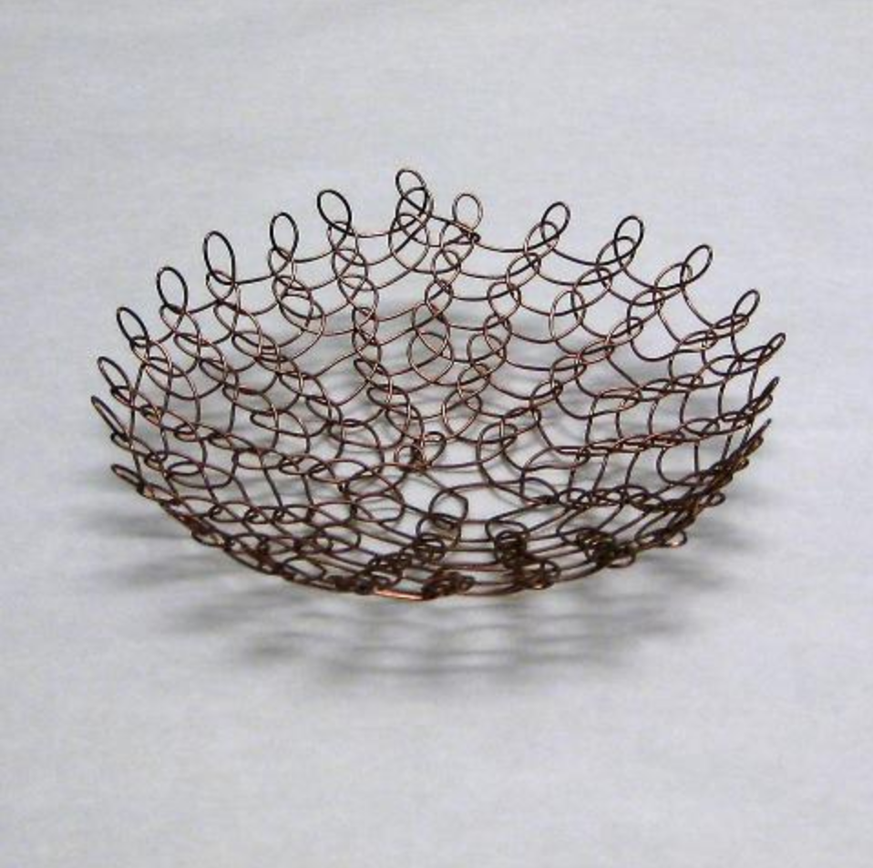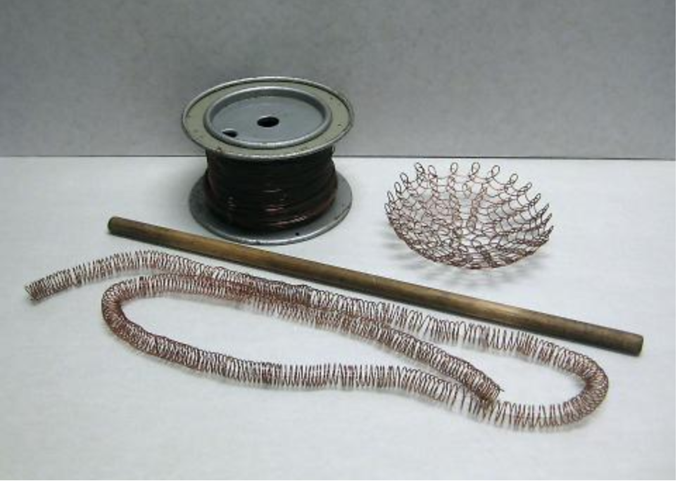
Untitled (Unfinished Looped Wire Basket), n.d., by Ruth Asawa (American, 1926–2013). Copper wire. Oakland Museum of California, Gift of the Artist, 2009.70.4.

Objective: Students will explore the gendered divide between craft and art while investigating Asawa’s sculpture work.

This lesson was modeled after the SPARKed Educator Guide: Ruth Asawa, by KQED. Several of the discussion questions were originally published through this source. The educator resource can be found at https://a.s.kqed.net/pdf/arts/programs/spark/314.pdf

Materials
Device with Internet access
Projector
Speakers

Common Core Content Standards (California)
Visual Arts 3.0: Understanding the historical contributions and cultural dimensions of the visual arts
3.VA:Re8: Interpret art by analyzing use of media to create subject matter, characteristics of form, and mood.
Visual Arts 4.0: Responding to, analyzing, and making judgments about works in the visual arts
5.VA:Cn11: Identify how art is used to inform or change beliefs, values, or behaviors of an individual or society.
6.VA:Re7.2: Analyze ways that visual components and cultural associations suggested by images influence ideas, emotions, and actions.
Prof.MA:Cn11: Demonstrate and explain how media artworks and ideas relate to various contexts, purposes, and values, such as social trends, power, equality, and personal/cultural identity.

Background
In 1956, ArtNews wrote the following statement about Ruth Asawa’s sculptural art: “These are ‘domestic’ sculptures in a feminine, handiwork mode.” Much of Ruth Asawa’s identity is intertwined with her life as a mother and homemaker. Throughout her career, her art was labeled domestic, thus excluding her from fine-art circles.

“Viewing Asawa’s work through the lens of her gender has identified the sculptures with the handicraft tradition of female decorative arts. It presented difficulties when trying to position her work alongside the major modern art movements of the postwar period, such as Abstract Expressionism in America and Modernism in Europe. Her aesthetic and materials distance her from these traditions and may have presented critics with difficulties in analyzing her work.”
Source: SPARKed. “The Family Business, Ruth Asawa, Visual Art.” KQED. Accessed May 22, 2020. https://a.s.kqed.net/pdf/arts/programs/spark/314.pdf
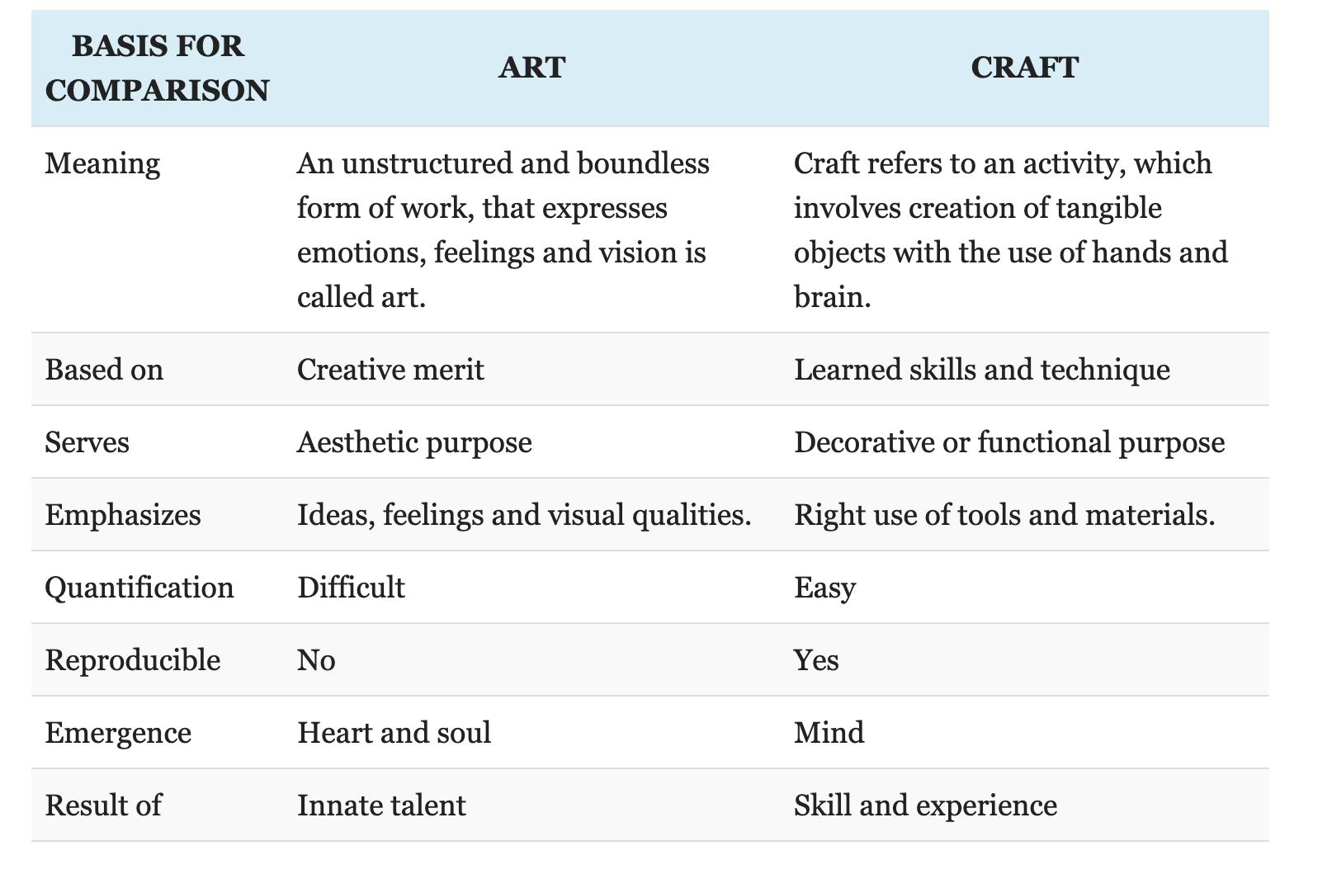

Source: Surbhi S. “Difference Between Art and Craft.” Key Differences. May 17, 2018. https://keydifferences.com/difference-between-art-and-craft.html

Procedure
- Introduce Ruth Asawa, showing students projections of her art through visual archive links above.
- Show the following video: Laura Morelli, “Is there a difference between art and craft?” TEDed. https://www.youtube.com/watch?v=tVdw60eCnJI
Optional: Have students answer the following questions about the TEDed video at https://ed.ted.com/lessons/is-there-a-difference-between-art-and-craft-laura-morelli/review_open#question-6 (8 multiple choice and 3 short answer)
- Initiate a discussion on art and craft.
  - Ask students to contribute what they think of when someone says craft or art. How do we define these terms? What are the differences between them? Record responses on the whiteboard.
  - Show the above Key Differences visual organizer for Art v. Craft.
- Challenge students to consider the following points:
- Is Asawa’s work aligned with domestic handicraft because weaving is a traditional craft technique (rather than an “art”)?
- Is this view compounded by the fact that Asawa is a woman, and is her work denigrated because of weaving’s association with “woman’s work”?
- Invite students to complete a writing prompt or discuss in groups: What are the differences between art and craft today? How should we define the terms? Do these differences lead to a greater appreciation or understanding of the work today?
  - Include requirements suitable for your class
Example: Use three sources in your writing assignment to support your thesis.

High School Modifications
During your discussions on craft and art, include the following questions to broaden the conversation.
- Do fine art and craft overlap?
- Are arts and crafts defined by their “high” and “low” cultural associations?
- Brainstorm culturally specific examples and consider how they are defined.
- Do art critics and museums promote different perceptions of art vs. craft?
- Is this changing in the contemporary world, and why might that be?
- Encourage students to use examples wherever possible to support their arguments and observations.

Lesson 3: Considering Public Art and Civic Participation (Grade 5 and above)
“Art is for everybody. It is not something that you should have to go to the museums in order to see and enjoy.” —Ruth Asawa

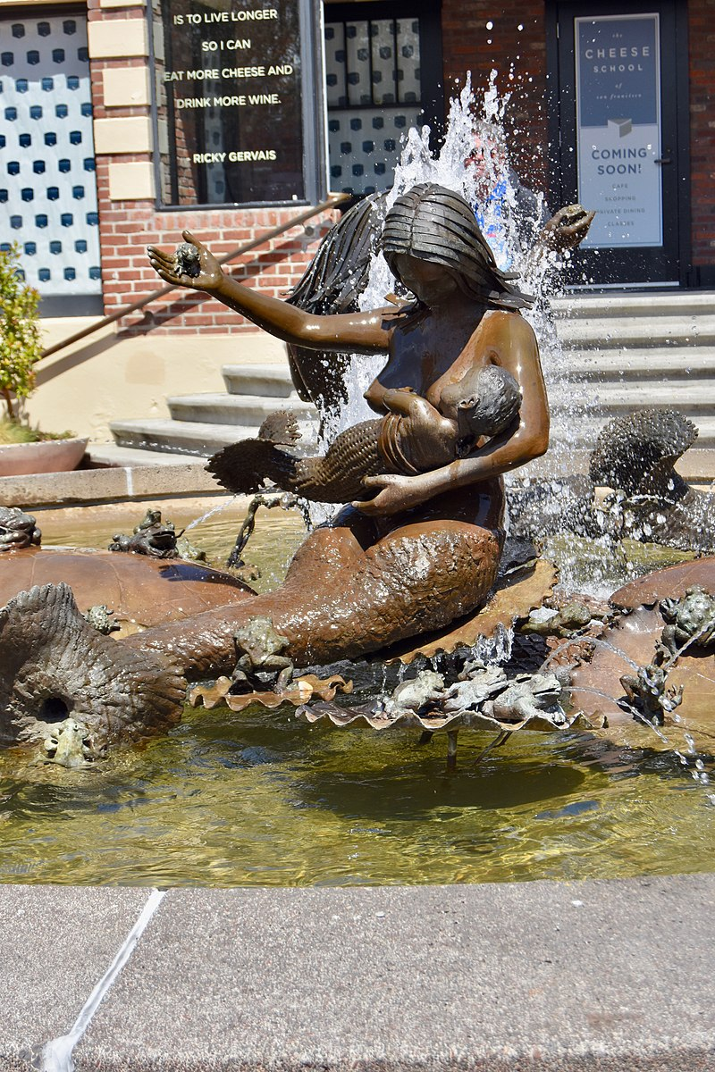
Objective: Students will consider how public art promotes civic participation and social commentary by 1) researching Bay Area public art and completing research assignments or, 2) submitting grant proposals for hypothetical public art.

Guiding Question: How can public art preserve the history, struggles, and achievements of individuals and groups and be used as a form of civic participation?

Common Core Standards (California)
Visual Arts
5.VA:Cn11: Identify how art is used to inform or change beliefs, values, or behaviors of an individual or society.
6.VA:Re7.2: Analyze ways that visual components and cultural associations suggested by images influence ideas, emotions, and actions.

Media Arts
K.MA:Cr1: Discover and share ideas for media artworks using play and/or experimentation.
6.MA:Cn11: Research and show how media artworks and ideas relate to personal life, and social, community, and cultural situations, such as personal identity, history, and entertainment.

Acc.MA:Cn11: Critically investigate and proactively interact with legal, technological, systemic, and vocational contexts of media arts, considering civic values, media literacy, digital identity, and artist/audience interactivity.
Andrea, 1968, by Ruth Asawa (American, 19262013). Photo by Nick Amoscato. CC BY 2.0
English Language Arts
6-12.SL.1: Engage effectively in a range of collaborative discussions (one-on-one, in groups, and teacher-led) with diverse partners on grade-appropriate topics and texts, building on others’ ideas and expressing their own clearly and persuasively.
SL.8.5: Integrate multimedia and visual displays into presentations to clarify information, strengthen claims and evidence, and add interest.

Vocabulary
Public art
Public art is not an art “form.” Its size can be huge or small. It can tower fifty feet high or call attention to the paving beneath your feet. Its shape can be abstract or realistic (or both), and it may be cast, carved, built, assembled, or painted. It can be site-specific or stand in contrast to its surroundings.

What distinguishes public art is the unique association of how it is made, where it is, and what it means. Public art can express community values, enhance our environment, transform a landscape, heighten our awareness, or question our assumptions. This is art for everyone, anytime.
Adapted from Bach, Penny Balkin. Public Art in Philadelphia. Philadelphia: Temple University Press, 1992.

Civic participation
encompasses a wide range of formal and informal activities. Examples include voting, volunteering, participating in group activities, and community gardening. Some are individual activities that benefit society (e.g., voting) or group activities that benefit either the group members (e.g., recreational soccer teams) or society (e.g., volunteer organizations). In addition to the direct benefit that civic participation provides to the community, it also produces secondary health benefits for participants. This summary focuses on the relationship between civic participation, health, and well-being.
Source: “Civic Participation.” HealthyPeople.gov. Accessed May 22, 2020.
https://www.healthypeople.gov/2020/topics-objectives/topic/social-determinants-health/interventions-resources/civic-participation

Background
“The distinction between domestic and nondomestic art would have made no sense to Asawa. ‘Art is doing,’ she wrote. ‘Art deals directly with life.’”
Source: Sullivan, Robert. 2013. “RUTH ASAWA, b. 1926: The subversively ‘domestic’ artist.” New York Times, Dec. 22, 2013. https://www.nytimes.com/news/the-lives-they-lived/2013/12/21/ruth-asawa/
“Public art plays an invaluable role in the process of community building. Not only does it establish and beautify public spaces, it expresses and supports a sense of neighborhood history, culture and identity and helps drive economic vitality. One aspect of increasing interest is participatory public art, in which the public plays an active role rather than merely being appreciative viewers.”
Source: Brennan, Jan. “Public Art and the Art of Public Participation.” National Civic League. Accessed May 22, 2020. https://www.nationalcivicleague.org/ncr-article/public-art-and-the-art-of-public-participation/

Materials
Examples of Ruth Asawa’s Public Art, found at
https://ruthasawa.com/art/public-commissions/
Sound Speakers
Projector
Internet Access
Video: “How to Look at Public Art: A Six-Year Old Explains”
https://youtu.be/MNO14EzuPM4

Procedure
- Ask Students to consider what public art is.
  - Take comments on what forms public art can take (e.g. performance, mural, sculpture, light installations, etc. )
  - Discuss if there are grey areas to public art? (E.g. little free book libraries, architectural design in single family homes, gardens, billboards)
    - Ask students to think of public art in their communities.
- Define public art for the class using the above definition.
- Watch this short KQED video with your class: https://youtu.be/MNO14EzuPM4
- Have students respond to the following questions in a journal response. Have students share their responses in pairs afterwards.
- What kinds of public art do you see in your community?
- What is the purpose of creating art that everyone can see? Why would somebody want to create public art instead of creating a piece for a museum or gallery?
- What impact, if any, does the public art have?
- Introduce civic participation using the above definition.
- Ask students to research and complete a paper or presentation on the history of a public art piece that makes a social statement. Ask students to choose a piece that engages with a social question or problem; it can be from any culture or in any style of work as long as it is appropriate. If using this assignment in a U.S. government class, assign criteria for a U.S. specific artwork. (Optional to assign as homework.)
Questions for Research Paper or Presentation
- What story or message does this public art piece convey?
  - Provide historical context
- What value, if any, does this public art have?
- What role does art play in political struggles?
- What is the role of art in community?
  - How does art educate people?
- Consider civic participation and public art, are the two related? If so, how?
  - Be sure to define civic participation and make an argument for why art is/isn’t a form of civic participation.
  - How can art be used to create change?

Alternate Project: Submit a Grant Proposal for a Hypothetical Public Art Work
Follow steps 1-5 in the lesson plan procedure.
Begin with a discussion on social problems currently happening or important historical moments
- Where would the public work be placed?
- What story would it tell?
- What purpose will this work of public art have?
- How does creating this art intersect with civic participation?

Lesson 4: The Japanese American Incarceration Experience: Loyalty and Civil Rights (Grade 8 and above)

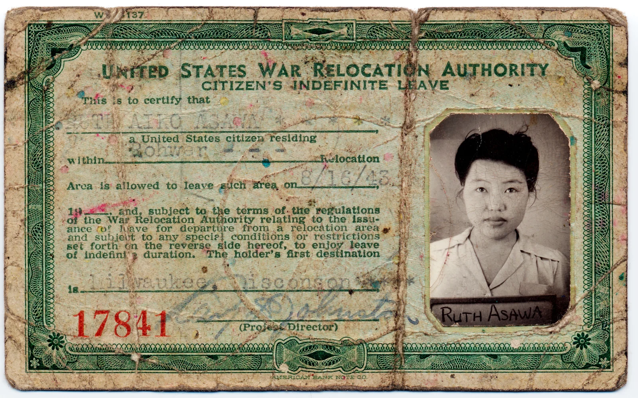
Ruth Asawa internment camp ID, 1943. Gelatin silver print. The National Portrait Gallery, Smithsonian Institution; gift of the children of Ruth Asawa. NPG.2016.2.
Objective: Students will examine the experiences and perspectives of incarcerated Japanese Americans during World War II.

Common Core Content Standards (California):
English Language Arts
W.4.8: Recall relevant information from experiences or gather relevant information from print and digital sources; take notes, paraphrase, and categorize information, and provide a list of sources.
W.4.9.a,b: Draw evidence from literary or informational texts to support analysis, reflection, and research.

National Standards for Civics and Government
Standard I.C.2: Explain the various purposes served by constitutions.
Standard IV.B.2: Evaluate, take, and defend positions on foreign policy issues in light of American national interests, values, and principles.
Standard IV.B.1: Evaluate, take, and defend positions on issues regarding personal rights.
Standard IV.B.1: Evaluate, take, and defend positions on issues regarding political rights.

History and Social Science
HSS-10.8: Students analyze the causes and consequences of World War II.
HSS-11.7: Students analyze America’s participation in World War II.
HSS 11.7.5: Discuss the constitutional issues and impact of events on the U.S. home front,
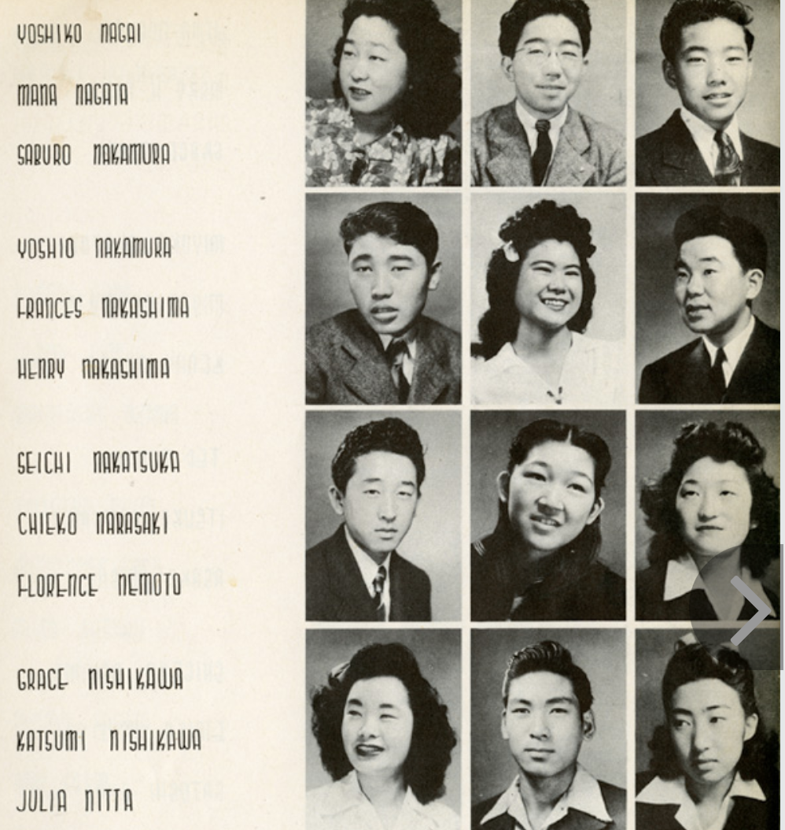
including the internment of Japanese Americans
HSS-PoAD.12.2: Students evaluate and take and defend positions on the scope and limits of rights and obligations as democratic citizens, the relationships among them, and how they are secured.

Materials
Internet Access
Sound Speakers
Projector
Virtual archive of the Rohwer Center High School Yearbook: http://www.ww2yearbooks.org/
yearbooks/arkansas-rohwer.php
Video, Ugly history: Japanese American incarceration Camps:
https://youtu.be/hI4NoVWq87M
Questionnaire distributed to male U.S.
citizens of Japanese ancestry over the age of
A page from the Rower Center High School Yearbook, 1944. Photo courtesy of the National WWII Museum.
seventeen, commonly known as the "Loyalty
Questionnaire”:
http://digitalcollections.archives.csudh.edu/
digital/collection/p16855coll4/id/7642

Guiding Questions
- Why was the United States so concerned about determining Japanese loyalty?
- How does loyalty change during wartime?
- How should loyalty be determined?
- Do you always have to agree with government policies to be loyal?
- In what ways can citizens express dissent if they do not believe in government policies?

Background
Ruth Asawa was one of many Japanese Americans incarcerated after the signing of Executive Order 9066. The Asawa family was forced to sell their farm and relocate to an incarceration camp. Asawa’s experience is illustrative of discrimination and the violation of American civil rights during the WWII era.

“Although Asawa had hoped to attend art school in Los Angeles, World War II and the signing of Executive Order 9066 changed everything. She was sixteen years old in February 1942 when her father was arrested by FBI agents and separated from his family for the next six years. A few months later, the family received orders to relocate. They were at the Assembly Center at Santa Anita racetrack for six months, and were later moved to a more permanent camp in Rohwer, Arkansas. Thanks in part to a sympathetic teacher, Ruth excelled in her art classes, and became the art editor of the class yearbook. She graduated from Rohwer High School in 1943, at a time when certain Nisei were permitted to leave camp to continue their studies, as long as they stayed away from the coasts.”
Source: Kunst, Frank. Guide to the Ruth Asawa Papers M1585, 2017. Online Archive of California. https://oac.cdlib.org/findaid/ark:/13030/c8s185rz/entire_text/

“The War Relocation Authority, a federal government agency, designed the curriculum for most internment camp schools. Undoubtedly, projects like these were meant to encourage nationalist sentiment as well as playing on the common theme of austere living, of roughing it on the frontier, that internment shared with romanticized versions of American mythology.

Education . . . in WWII internment camps both hindered and facilitated assimilation into mainstream American values—encouraging a sense of cultural belonging while simultaneously alienating and dehumanizing them through the political realities of imprisonment.”
Source: “Education.” The United States in World War II: Historical Debates About America at War. Oberlin College. Accessed May 22, 2020. http://oberlinlibstaff.com/omeka_hist244/exhibits/show/japanese-internment/education

“At first glance, the pages of the 1944 Résumé yearbook make Rohwer Center High School seem like any other high school on the Home Front, rich with student life, activities, victory gardens and dances. In reality, however, the experience of Rohwer Center students couldn’t have been more different. The school, located at the Rohwer War Relocation Center, was created to educate the children of Japanese American descent who were forced from their homes along the West Coast of the United States and required to live behind barbed wire for the duration of WWII, far from the homes they knew. Located in remote areas of the country, these camps were modeled after military facilities: tar-paper barracks, central latrines and washrooms, mess halls and recreation halls. Guard towers and barbed wire were everyday features of the lives of these Americans. Roughly 120,000 men, women, and children were held without trials, and nearly 70,000 of those evicted were American citizens. Ultimately, not a single Japanese American person was ever convicted of espionage or acts of sabotage against the United States. Despite these children (and many of their teachers) being deprived of their basic rights, what message do school administrators have to these students about their future?”
Source: “Rowher Center High School.” See You Next Year!: High School Year Books from WWII. The National WWII Museum. Accessed May 22, 2020.
http://www.ww2yearbooks.org/yearbooks/arkansas-rohwer.php

Vocabulary
Nisei (noun)
a child of Japanese immigrants who is born and educated in America and especially in the U.S.
Source: Merriam-Webster

Issei (noun)
a Japanese immigrant especially to the U.S.
Source: Merriam-Webster

Loyal (adjective)
unswerving in allegiance, faithful to one's lawful sovereign or government
b: faithful to a private person to whom faithfulness is due: a loyal husband
c: faithful to a cause, ideal, custom, institution, or product: a loyal churchgoer, loyal to the party of their forebears
Source: Merriam-Webster

Assimilate (verb)
to absorb into the cultural tradition of a population or group
to make similar
Source: Merriam-Webster

Procedure
- Begin by introducing Executive Order 9066 along with historical context, if not previously covered.
  - Executive Order 9066: Executive Order 9066: The President Authorizes Japanese Relocation
- View this TedEd video with your class about the experience of Aki Kurose: https://youtu.be/hI4NoVWq87M
- Virtually view the Rowher Center High School Yearbook; while viewing, ask students to read the comments and labels. Have students record any comments that are notable or out of the ordinary.
http://www.ww2yearbooks.org/yearbooks/arkansas-rohwer.php
- Ask students to consider what daily life looked like in an incarceration camp; what things would have been prohibited that would affect a normal life? Have students refer to the yearbook and video in their responses.
  - Option to share in groups or complete a journal prompt.
  - Option to show “U.S. Propaganda Film Clip of ‘Normal’ Life in WWII Japanese Incarceration Camps”: https://www.history.com/news/japanese-american-internment-camps-wwii
- Discuss the treatment of prisoners in the incarceration camp. Lead a class discussion on student comments from the prior step. Introduce the definition of “loyalty” from Merriam-Webster and the guiding questions.
  - Ask students to consider loyalty in the time of WWII and Japanese American incarceration, as many nisei and issei were feared to be spies for the Axis powers and considered “public dangers.” Why did the United States feel the need to ensure loyalty? How can loyalty be determined? Do you have to agree with the government to be loyal? Does a Japanese American have to give up their cultural connections to be loyal?
- View the Loyalty Questionnaire. Explain that “Refusal to complete the questionnaire, qualified answers, or ‘no’ answers to a question about serving in the armed forces (number 27) and for swearing allegiance to the Japanese emperor/foreign governments (number 28) were treated as evidence of disloyalty.”
Source: Burns, Maureen, Nicole Gilbertson, and Gregory Williams. “Japanese Internment Camps during WWII.” EDSITEment! NEH. Accessed May 22, 2020. https://edsitement.neh.gov/lesson-plans/japanese-american-internment-camps-during-wwii
- Have students in groups discuss the ways that loyalty was enforced and upheld; invite students to consider what mechanism the United States government used to assimilate Japanese Americans and remove their connections from Japan.
- Conclude with a class discussion, group poster board projects, or an extension option below.
Poster Board
  - Create a visual organizer including content from the sources in the lesson plan. Students should include what Executive Order 9066 was and how it affected Japanese Americans.

Extensions
- Ruth Asawa first learned to weave during her incarceration at Rowher, through her volunteer work weaving camouflage nets (Varner 2016). Other artists such as Chiura Obata, Kay Sekimachi, and Arthur Okamura were also incarcerated during WWII and found solace through creating or teaching art. Have students explore the artwork made by Japanese American prisoners in the incarceration camps. Here are a few places to start:
- Video: “The Art of Gaman: Arts and Crafts from the Japanese American Internment Camps.” Smithsonian Magazine. YouTube video. Mar. 17, 2010.
- Stamberg, Susan. “The Creative Art of Coping in Japanese Internment.” NPR. May 12, 2010. https://www.npr.org/templates/story/story.php?storyId=126557553
- “Artistic Expression.” The United States in World War II: Historical Debates about America at War. Oberlin College History 244 Virtual Exhibition. Accessed May 22, 2020. http://oberlinlibstaff.com/omeka_hist244/exhibits/show/japanese-internment/arts
- Ahn, Abe. “Years After Controversial Sale, Artworks from Japanese Internment Camps Go on View.” Hyperallergic. Feb. 21, 2018. https://hyperallergic.com/427975/contested-histories-japanese-american-national-museum/
Discuss: What can you learn about the Japanese American prisoners from looking at their artwork?
- Include a discussion and writing assignment pertaining to the First, Fourth, and Fifth Amendments to the Constitution. Direct students to analyze how Japanese American rights were violated, and what legal considerations led to the rulings of Korematsu v. United States and Endo v. the United States.
- Dramatic presentations: Divide students into groups and instruct them to complete a short dialogue discussing life in incarceration camps. Further instructions can be found at Japanese-American Internment During World War II

Further Resources
The California State University. CSU Japanese American Digitization Project. Accessed May 22, 2020.
https://scalar.usc.edu/works/csujad-exhibit/index

“Education.” The United States in World War II: Historical Debates about America at War. Oberlin College.
http://oberlinlibstaff.com/omeka_hist244/exhibits/show/japanese-internment/education

Guise, Kim. “High School Life at Rohwer War Relocation Center.” From the Collection. The National World War II Museum. Accessed May 22, 2020.
https://www.nationalww2museum.org/war/articles/high-school-life-rohwer-war-relocat
ion-center

Horne, Madison. “These Photos Show the Harsh Reality of Life in WWII Japanese-American Internment Camps.” History.com. February 21, 2020.
https://www.history.com/news/japanese-internment-camp-wwii-photos

“Timeline of Events for Japanese Internment Camps “ EDSITEment! NEH. Accessed May 22,
2020.
https://edsitement.neh.gov/sites/default/files/resource/Timeline%20of%20Events%20for%20Japanese%20Internment%20Camps_1.pdf

Appendix A
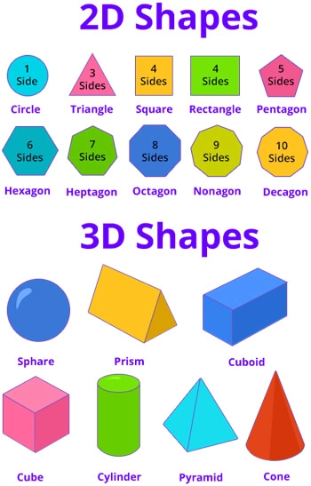

Source: “Geometry Games for 2nd Graders.” SplashLearn. Accessed May 22, 2020.
https://www.splashlearn.com/geometry-games-for-2nd-graders

Resources

General Resources
Cover Image: Untitled (Ruth Asawa holding a looped wire sculpture), 1952, by Imogen Cunningham (American, 1883-1976). Sepia-toned gelatin silver print. FAMSF, Gift of Ruth Asawa and Albert Lanier, 2006.114.1.

Chen, Milton and Ruth Cox. “Ruth Asawa: ‘Art Is for Everybody.’” Edutopia. February 2, 2007. https://www.edutopia.org/art-everybody

David Zimmerman Gallery. Ruth Asawa Press Release, Sep 13–Oct 21, 2017, Artsy.net https://www.artsy.net/show/david-zwirner-ruth-asawa

de Young Museum. “Ruth Asawa, A Working Life.” Google Arts and Culture. Accessed May 20, 2020.
https://artsandculture.google.com/exhibit/ruth-asawa-a-working-life/hAIygGBPp11bIg

Kunst, Frank. “Guide to the Ruth Asawa Papers M1585, 2017. Online Archive of California. Accessed May 22, 2020.
https://oac.cdlib.org/findaid/ark:/13030/c8s185rz/entire_text/

Martin, Douglas. “Ruth Asawa, an Artist Who Wove Wire, Dies at 87.” New York Times. Aug. 17, 2013.
https://www.nytimes.com/2013/08/18/arts/design/ruth-asawa-an-artist-who-wove-wire
-dies-at-87.html

SPARKed. ”The Family Business, Ruth Asawa, Visual Arts.” KQED. Accessed May 22, 2020.
https://a.s.kqed.net/pdf/arts/programs/spark/314.pdf

Lesson 1: Wire Sculpture Explorations (Grades K–12)
Image: Untitled, approx. 1955, by Ruth Asawa (American, 1926–2013). Copper and brass wire. de Young Museum. Gift of Jacqueline Hoefer, 2006.76.1. © Estate of Ruth Asawa.

Balsbaugh, Amy. “Wire Explorations a La Asawa - 1st Grade Tinkering - Week 6.” Instructables Living.
https://www.instructables.com/id/Wire-Explorations-a-la-Asawa-1st-Grade-Tinkering-W/

Further Research
“Positive and Negative Space: Explore and Experiment with Positive and Negative Space.” Whitney Museum of American Art. Accessed May 22, 2020.
https://whitney.org/education/forteachers/activities/115

Center for Art and Inquiry. “Ruth Asawa/Milk Carton Sculpture.” Exploratorium. Accessed May 22, 2020.
https://www.exploratorium.edu/arts/begin-here/ruth-asawa

Lesson 2: Craft and Design vs. Fine Art, A Gendered Lens (Grade 5 and above)
Image: Untitled (Unfinished Looped Wire Basket), n.d., by Ruth Asawa (American, 1926-2013). Copper wire. Oakland Museum of California, Gift of the Artist, 2009.70.4.

Morelli, Laura. “Is there a difference between art and craft?” TEDEd. Accessed May 22, 2020.
https://ed.ted.com/lessons/is-there-a-difference-between-art-and-craft-laura-morelli#watch

SPARKed. “The Family Business, Ruth Asawa, Visual Arts.” KQED. Accessed May 22, 2020. https://a.s.kqed.net/pdf/arts/programs/spark/314.pdf

Further Research
Callen, Anthea. “Sexual Division of Labor in the Arts and Crafts Movement.” Woman's Art Journal, vol. 5, no. 2, 1984, pp. 1–6. JSTOR. Accessed 11 May 2020.
www.jstor.org/stable/1357958

Jefferson, Margo. 2005. “Beyond Cultural Labeling, Beyond Art Versus Craft.” The New York Times, March 22, 2005.
https://www.nytimes.com/2005/03/22/arts/design/beyond-cultural-labeling-beyond-art-
versus-craft.html

Lesson 3: Considering Public Art and Civic Participation (Grade 5 and above)
Image: Fountain, Ghirardelli Square. July 18, 2018, by Nick Amoscato. CC BY 2.0. Retrieved from commons.wikimedia.org.

“Introduction to Public Art Lesson Plan: An Introduction to Public Art in Philadelphia for 4th/5th Grader. ” Association for Public Art. Accessed May 22, 2020.
https://www.associationforpublicart.org/resources/public-art-lesson-plans/introduction-to-public-art-lesson-plan/

Sullivan, Robert. “RUTH ASAWA, b. 1926: The subversively ‘domestic’ artist.” New York Times, Dec. 21, 2013.
https://www.nytimes.com/news/the-lives-they-lived/2013/12/21/ruth-asawa/

Further Resources
Brennan, Jan. “Public Art and the Art of Public Participation.” National Civic League. Fall 2019.
https://www.nationalcivicleague.org/national-civic-review/issue/fall-2019-volume-108-number-3/?popup=true

Facing History and Ourselves. “Public Art as a Form of Participation.” Standing up for Democracy. Accessed May 22, 2020.
https://www.facinghistory.org/resource-library/standing-democracy/public-art-form-participation

Lesson 4: The Japanese American Incarceration Experience: Loyalty and Civil Rights
Image: Ruth Asawa internment camp ID, 1943. Gelatin silver print. The National Portrait Gallery, Smithsonian Institution; gift of the children of Ruth Asawa. NPG.2016.2.

Image: The National World War II Museum. “Rowher Center High School 1944 Yearbook.” See You Next Year! High School Yearbooks from WWII. Accessed May 22, 2020.
http://www.ww2yearbooks.org/yearbooks/arkansas-rohwer.php

“Education.” The United States in World War II: Historical Debates about America at War.
Accessed May 22, 2020.
http://oberlinlibstaff.com/omeka_hist244/exhibits/show/japanese-internment/education

Guise, Kim. “High School Life at Rohwer War Relocation Center.” The National World War II Museum. Accessed May 20, 2020.
https://www.nationalww2museum.org/war/articles/high-school-life-rohwer-war-relocation-center

Varner, Natasha. 2016. “Visionary Sculptress Ruth Asawa.” Densho Blog. Mar. 28, 2016.
https://densho.org/ruthasawa/

Further Resources
National Archives. n.d. “Japanese-American Internment During World War II.” March 17, 2020.
https://www.archives.gov/education/lessons/japanese-relocation

