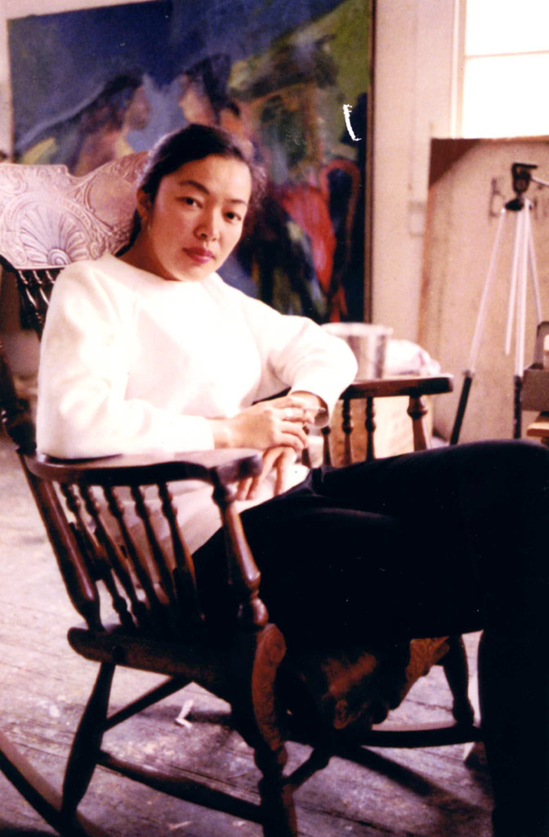

Bernice Bing
(1936–1998)

Teacher Packet
©️2020

Table of Contents

Biography: Bernice Bing 3
Lesson 1: Compare and Contrast—Hasegawa and Bing (grades 1st – 8th) 5
Lesson 2: Researching Bay Area Arts Organizations (grades 3rd – 7th ) 9
Lesson 3: Identity, Intersectionality (grades 6th –12th and beyond) 12
Lesson 4: East Asian Art Traditions and Bernice Bing (grades 5th-12th 15
Resources 19
Lesson 1 19
Lesson 2 19
Lesson 3 20
Lesson 4 20

Biography: Bernice Bing

Bernice Bing (1936–1998), or “Bingo,” was a queer Chinese American Abstract Expressionist artist. Born in San Francisco’s Chinatown, Bing’s early life was filled with adversity. Orphaned at the age of 6, Bing lived in a variety of homes including an orphanage, her grandmother’s, and with several white foster families. The Queer Cultural Exchange writes, “Through art, Bing dealt with the remoteness of her family and life set in a transplanted culture and the non-Asian world she encountered.” In 1958, after being awarded a scholarship, Bing began attending California College of Arts and Crafts. Here, under the influence of her professors, Bernice began exploring the intersection of being an American-born, queer, ethnically Chinese artist. Her fascination with East Asian philosophy, especially Zen Buddhism, can be seen throughout her work. In 1961, Bing graduated with an MFA, after transferring to what is now known as the San Francisco Art Institute. She established herself in the San Francisco art scene, mingling with the Beat movement. Bernice Bing was a devoted artist and activist, who was responsible for supporting many arts organizations throughout the Bay Area, such as SomArts. Bing’s contributions to the New York-centric, male-dominated field of Abstract Expressionism were overlooked during her life, but her work of exploring identity and supporting the arts are contributions that will inspire generations to come.

Lesson Plans/ Activities
In this Bing inspired Teacher Packet, students and teachers will have the ability to investigate the following prompts :
- Bing’s artistic style and influences from Zen artist Saburo Hasegawa (grades 1st -8th)
- A Research Assignment to Explore the History and Contributions of Several Bay Area Arts Organizations Affiliated with Bing (grades 3rd – 7th).
- Intersectionality Through the Lens of Bing’s Identity (grades 6th- 12th and beyond)
- The Influence of Zen Buddhism Beliefs and Calligraphy in Bing’s art, (grades 5th and beyond)
  - Optional Brushpainting Extension—Bernice Bing-inspired art project (grades 3rd-12th)

Keywords/Object of Study: Intersectionality, Abstract Expressionism, Asian-American Female Artists, Bay Area Artists, Queer Artists of Color, Abstract Zen Art, East Asian Philosophy, Buddhist Philosophy, Zen Philosophy, Appropriation, Arts Organizations, Arts Advocates

Vocabulary
Abstract Expressionism (noun)
“is a term applied to a movement in American painting that flourished in New York City after World War II, sometimes referred to as the New York School or, more narrowly, as action painting. The varied work produced by the Abstract Expressionists resists definition as a cohesive style; instead, these artists shared an interest in using abstraction to convey strong emotional or expressive content.

Abstract Expressionism is best known for large-scale paintings that break away from traditional processes, often taking the canvas off of the easel and using unconventional materials such as house paint. While Abstract Expressionism is often considered for its advancements in painting, its ideas had deep resonance in many mediums, including drawing and sculpture.”
Source: MomaLearning, Abstract Expressionism

Lesson 1: Compare and Contrast—Hasegawa and Bing (grades 1st – 8th)
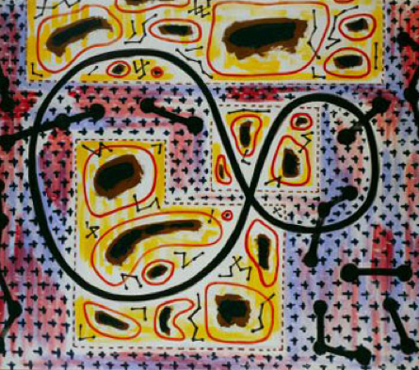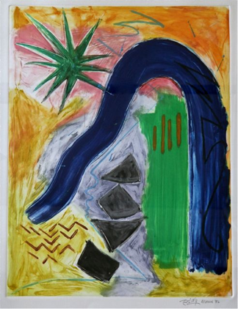
Locus of a Butterfly, 1937, Saburo Hasegawa, Oil on canvas, 130x163 cm. National Museum of Modern Art, Kyoto

March ’86, 1986, Bernice Bing, Monoprint. Curtesy of the Calabi Gallery

Objective: Students will explore abstract-inspired work by Bing and Hasegawa through a compare-and-contrast activity.

Content Standards
K.VA:Re8: Interpret art by identifying subject matter and describing relevant details.
Visual Arts 1.0: Processing, analyzing, and responding to sensory information through the language and skills unique to the visual arts.
1.VA:Re7.2: Compare images that represent the same subject.
2.VA:Re8: Interpret art by identifying the mood suggested by a work of art and describing relevant subject matter and characteristics of form.
Visual Arts 3.0: Understanding the historical contributions and cultural dimensions of the visual arts.
3.VA:Re8: Interpret art by analyzing use of media to create subject matter, characteristics of form, and mood.
Visual Arts 4.0: Responding to, analyzing, and making judgments about works in the visual arts.
6.VA:Re7.2: Analyze ways that visual components and cultural associations suggested by images influence ideas, emotions, and actions.

Background
“While Bernice enrolled at [CCAC], she was taught by Saburo Hasegawa, a notable abstract Zen artist. Bing was inspired by Hasegawa’s attitude, identity, and artwork. She incorporated ‘calligraphy-inspired abstraction’ in her paintings.”

“‘One of Bing’s most important encounters is with Hasegawa (who died [in 1958]), who had been brought over from Japan by the school. ‘Earlier on he had been very influenced by European painting and then he had studied Zen. He practiced Zen, and used his Zen meditation in his own art. His work was dreamy abstract and quite calligraphic and beautiful. He introduced a whole attitude that was completely foreign to me. I had no idea what it meant to be an Asian woman, and he got me started thinking about that. I was in awe of him. He would wear his traditional Zen robes—I don’t think I ever saw him in Western dress—a long black robe, and he would tell stories about how he would sit zazen, and how he would get whacked on the back for falling asleep! On the first day in his drawing class, he marked where we were sitting and then we had to sit in that same place during the whole semester. And the model would be in the same position all semester, too. We would draw that position until it was ingrained and etched in our heads. In Hasagawa’s class, we would do color theory with origami paper. His methodology of teaching was unique. He had a strong Japanese accent and it was hard to understand him because of that, and also because he talked in metaphors.’ “
Source : http://www.queerculturalcenter.org/Pages/Bingshow/BBCaucas.html

Materials
Artworks : Hasegawa and Bing (PPT)
Projector
Student Template, located in Appendix A
Pencils

Procedure:
- Introduce students to Bing and Hasegawa as artists. Explain that Hasegawa was one of Bing’s teachers at CCAC.
  - Hasegawa Biography can be found at either: https://en.wikipedia.org/wiki/Saburo_Hasegawa
  - Johnson M. & Hart D. 2019. The Saburo Hasegawa Reader.
A short Hasegawa Biography
- Distribute student worksheets and give directions for the activity.
  - Students will practice close-looking at two Asian American artists’ works. For each set of paintings, students should list 2 similarities and 2 differences.
  - Prepare to display paintings on a projector.
- Begin guided slideshow. Ask students throughout the presentation to consider the colors, lines, shapes, and objects depicted in each image. What do they notice?

Conclusion
- Have students conclude the assignment by answering the following three questions in a writing assignment or group share.
  - What were some similarities that were seen in every painting?
  - What is notably distinct in each artist’s work?
  - Pick 1-2 paintings and consider how this painting makes you feel. What do you think the artist was trying to convey with this work?

Extension
Consider further extending this lesson by comparing the two artists’s work to traditional Zen paintings or Abstract Expressionist artists of the same era. Invite students to consider how the cultural identity of Bing and Hasegawa changed their understanding of abstract art.

Lesson 2: Researching Bay Area Arts Organizations (grades 3rd – 7th )

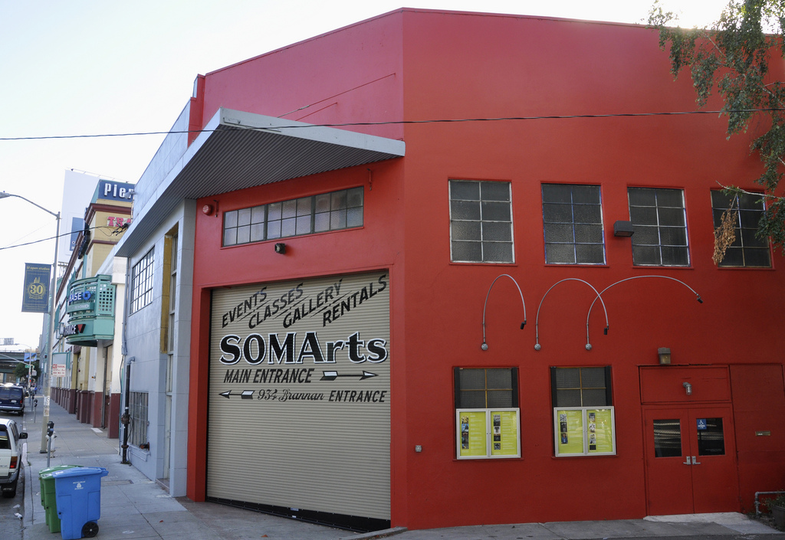

Objective: Students will investigate and research the history of arts organizations and their contributions in the Bay Area.

Common Core Standards
W.K.7: Participate in shared research and writing projects (e.g., explore a number of books by a favorite author and express opinions about them).
W.4.7: Conduct short research projects that build knowledge through investigation of different aspects of a topic.
W.4.9.a, b: Draw evidence from literary or informational texts to support analysis, reflection, and research.
W.5.7: Conduct short research projects that use several sources to build knowledge through investigation of different aspects of a topic.
W.5.8: Recall relevant information from experiences or gather relevant information from print and digital sources; summarize or paraphrase information in notes and finished work, and provide a list of sources.
W.5.9: Draw evidence from literary or informational texts to support analysis, reflection, and research
RI.5.9: Integrate information from several texts on the same topic in order to write or speak about the subject knowledgeably.
LIB.6.4.3: Appreciate and respond to creative expressions of information: a. Demonstrate a variety of methods to engage the audience when presenting information (e.g., voice modulation, gestures, questions). b. Appreciate a range of creative forms of expression (e.g., poetry, drama, film, literature, visual arts). c. Evaluate one’s own research process and that of others in a respectful, cooperative, and productive way.

Introduction
“Bernice Bing was a prominent and prodigious community arts activist. Among her many contributions, in 1968 Bing was invited by the director of the National Endowment for the Arts to speak on a panel devising new ways to engage people of color in contemporary art. Out of that discussion, funding was granted to the San Francisco Arts Commission to develop the Neighborhood Arts Program, which Bing co-organized from 1969–71. Bing also established an arts workshop in conjunction with a local Chinatown gang after gang rivalry exploded in gun violence, leaving five dead and eleven injured (none of whom were gang affiliated) at the Golden Dragon Restaurant in 1977. Bing worked with the Wah Ching gang to create an arts workshop for adolescent boys to channel their energies. She also co-founded SCRAP (Scroungers’ Center for Reusable Art Parts), directed the South of Market Cultural Center, and was a participating member of women’s arts organizations including Rural Women’s Resources Inc., Women’s Caucus for the Arts, the Asian American Women’s Artist Association, and Lesbian Visual Artists.”
Source: https://www.artspace.com/magazine/art_101/the_big_idea/the-other-art-history-the-gay-lesbian-and-female-abstract-expressionists-part-ii-55444

Vocabulary
Advocate (noun)
one who defends or maintains a cause or proposal, e.g. an advocate of liberal arts education; one who supports or promotes the interests of a cause or group

Materials
Web Access
Bing ArtWorks (PPT)
Projector

Procedure
- Decide if students are to work individually or in groups. Arrange for web access in the classroom, or determine if assignment can be taken home.
- Introduce students to Bernice Bing, a Bay Area arts advocate.
  - Define “advocate” for your class.
  - Optional: Show Bing ArtWorks (PPT) to familiarize students with Bing’s art contributions and contextualize the assignment.
  - Introduce Bing’s biography and the above quote, highlighting Bing’s involvement with community arts organizations.
- Introduce the assignment: Students will research a Bay Area arts organization and either respond to a writing prompt or create a presentation.
- Assign students an art organization to research from the following:
  - SCRAP
  - SomArts or South of Market Cultural Center
  - Neighborhood Arts Program
  - Asian American Women’s Artist Association
  - Women’s Caucus for the Arts
- Provide time for students to research their assigned organization.
  - Ask students to begin their search with the organization website, and then further explore through an internet search.
- Have students answer the following questions in a writing prompt or presentation.
  - What does your arts organization do/did?
  - When was it established? Who contributed to founding the organization?
  - What communities does your organization serve?
  - Why is your organization important to society?
- Conclude with a discussion or brainstorm of alternate arts organizations, or ways the arts can help people, and the community.

Lesson 3: Identity, Intersectionality (grades 6th –12th and beyond)
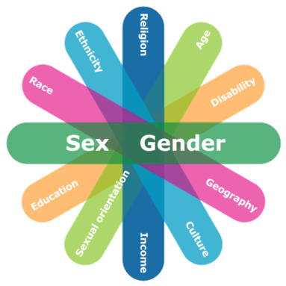

Objective: Students will consider their unique identities and be introduced to intersectionality, using Bernice Bing to illustrate the many aspects of identity.

Grade levels: Middle school, high school and beyond

Content Standards (California):
8.VA:Cn11: Distinguish different ways art is used to represent, establish, reinforce, and reflect group identity.
Prof.MA:Cn11: Demonstrate and explain how media artworks and ideas relate to various contexts, purposes, and values, such as social trends, power, equality, and personal/cultural identity..
5.2.1.G: Explain how culture, media, and other factors influence perceptions about body image, gender roles, and attractiveness.
7–8.2.2.G: Evaluate how culture, media, and other people influence our perceptions of body image, gender roles, sexuality, attractiveness, relationships, and sexual orientation
HSS 11.11: Students analyze the major social problems and domestic policy issues in contemporary American society.
ID.3) of the Teaching Tolerance Social Justice Standards: “Students will recognize that peoples’ multiple identities interact and create unique and complex individuals.”

Materials
Projector
Colored Pencils or Markers
Speakers
Computer
Identity Axis Worksheet

Introduction
“Bernice Bing, or “Bingo,” was, in many ways, an artist’s artist. She was a well-respected figure in the San Francisco arts community during the 1950s and ’60s, but her Abstract Expressionist paintings have largely been left out of the movement’s subsequent history. It is, of course, unsurprising that the works of a Chinese American and lesbian artist would fall through the cracks of art history.”
Jabbar, Sumayra, “Overlooked Abstract Expressionist Bernice Bing Searched for Identity through Painting,” Artsy.net, November 21, 2019
https://www.artsy.net/article/artsy-editorial-overlooked-abstract-expressionist-bernice-bing-searched-identity-painting

“In the words of the New Yorker’s art critic Calvin Tomkins, ‘the leading artists of Pollock’s and de Kooning’s generation had been, almost without exception, aggressively male, hard-drinking, and heterosexual.’

For Bing, this new spirit of Abstract Expressionism represented a way for her to rebel against a middle-class, white, heteronormative upbringing. According to a 1999 essay published by the Queer Cultural Council, Bing began to ‘re-define her sense of identity in opposition to the prescribed “normalcy” of white middle class foster homes and the orphanage in which she was raised after her mother’s death—as well as against traditional gender/cultural expectations of her extended Chinese family in California.’ “
Lee, Shannon, “The Other Art History: The Gay, Lesbian, and Female Abstract Expressionists (Part II),” Art Space, 21, May 2018 https://www.artspace.com/magazine/art_101/the_big_idea/the-other-art-history-the-gay-lesbian-and-female-abstract-expressionists-part-ii-55444

Vocabulary
Intersectionality (noun)
Intersectionality refers to the social, economic, and political ways in which identity-based systems of oppression and privilege connect, overlap, and influence one another.
Source: Teaching Tolerance

Intersectionality (noun)
Coined by Kimberlé Crenshaw in 1989, intersectionality refers to an analytical framework that views people through the interaction of their social identities (including gender, race, sexual orientation, socioeconomic class, etc.) resulting in a unique lived social experience of oppression and privilege, as opposed to an additive model of oppression that views people as the sum of their social identities
Source: Crash Course in Intersectionality

Privilege (noun)
operates on personal, interpersonal, cultural, and institutional levels and gives advantages, favors, and benefits to members of dominant groups at the expense of members of target groups
Source: Crash Course in Intersectionality

Oppression (noun)
the combination of prejudice and institutional power which creates a system that discriminates against target groups and benefits other dominant groups
Source: Crash Course in Intersectionality

Procedure
- Watch the following short clips (depending on your student’s grade levels and prior background) to introduce intersectionality
  - https://youtu.be/w6dnj2IyYjE — great for younger students
  - https://www.youtube.com/watch?v=O1islM0ytkE
- Introduce Bernice Bing’s biography and ask students to consider the many identities of Bing. Ask students to contribute identities they heard in her biography, list comments on the white board.
  - Examples of Bing’s Identity are: Chinese, American-born, low socioeconomic status, female-identifying, queer, orphaned
- Begin a discussion on privilege. Define the term for students.
  - Have students watch the following video on privilege: Sometimes You’re A Caterpillar, https://www.youtube.com/watch?v=hRiWgx4sHGg
- Prepare students for their assignment by giving directions and distributing the Intersecting Axis worksheet found here, invite students to mark their corresponding identities: Identity Axis
- Conclude activity with a discussion or writing prompt.
  - What surprised you today?
  - Did you learn anything new?
  - How can we use intersectionality to create a better, just world?
  - How is identity important to art, and getting recognized as an artist?
  - Where do we see privilege in the art world?

Extension Lesson Plans
- (Extension for older students, or advanced art classes) Facilitate a discussion on the challenges of being a queer artist of color during the 1960s.
  - Have students read the following article, or summarize main points: “How Asian-American Artists Made a Mark on Abstract Expressionism” https://hyperallergic.com/420734/how-asian-american-artists-made-a-mark-on-abstract-expressionism/
- Alternate lesson plan, with narrative stories from women of color. “This activity is intended to help students understand the intense oppression that women of color face. Additionally, this activity helps students understand that all individuals, who identify as having more than one oppressed and denigrated social identity face more obstacles.”
https://p4cintheborderlands.files.wordpress.com/2017/08/lesson-plan-an-introduction-to-intersectionality.pdf

Lesson 4: East Asian Art Traditions and Bernice Bing (grades 5th-12th )

Objective: Students will be exposed to East Asian art traditions through the lens of a contemporary Chinese American artist, Bernice Bing

Art Extension Student Objective: Students will create a work of art inspired by Bing’s signature artworks, using brush painting techniques.

Content Standards
2.VA:Cn11: Compare and contrast cultural uses of art from different times and places.
Visual Arts 3.0: Understand the historical contributions and cultural dimensions of the visual arts.
4.VA:Re7.2: Interpret art by analyzing use of media to create subject matter, characteristics of form, and mood.
6.VA:Re7.2: Analyze ways that visual components and cultural associations suggested by images influence ideas, emotions, and actions.
5.VA:Re7.2: Identify and analyze cultural associations suggested by visual imagery.

Associated standards
HSS-7.5: Students analyze the geographic, political, economic, religious, and social structures of the civilizations of medieval Japan.

Materials
Projector
Speakers
Computer
Bing ArtWorks (PPT)
AAM resource: Zen Buddhism : https://education.asianart.org/resources/zen-buddhism/
Youtube video: 3 Minute Zen Introduction : https://youtu.be/RozWiUA-GCk
Zen Artworks (PPT)
Visual Vocabulary of Brushstrokes
Inking Techniques

Art Extension
Sumi ink
Rice paper
Classic ink brush (If available, option to use regular paint brush)

Introduction
Bernice Bing was widely influenced by calligraphy and Zen practices. Much of Bing’s work involved spiritual components connecting to East Asian philosophy and aesthetic practices. She used the exploration of these to support her individual perspective of being an American-born, culturally Chinese artist, who experienced feelings of otherness from both groups.

Ultimately Bing created artwork that represented her intersectional identity, and unique devotion to spirituality. “Combining Western abstraction with the Eastern philosophies and poetry of Po Chu-i, Chuang Tzu, Lao Tzu, Shakyamuni, and Wang Hsi-chih, Bing was able to develop a language of abstraction that was existentially her own.”
Source : Lee, Shannon, “The Other Art History: The Gay, Lesbian, and Female Abstract Expressionists (Part II),” Art Space, May 21, 2018 https://www.artspace.com/magazine/art_101/the_big_idea/the-other-art-history-the-gay-lesbian-and-female-abstract-expressionists-part-ii-55444

Vocabulary
Zen (Sanskrit dhyana; Chinese chan)
Literally, meditation. A school of Mahayana Buddhism brought to China from India in the 6th century by the Indian monk-ascetic Bodhidharma. In China, the religion would be influenced by the indigenous philosophy and religion of Taoism. By the 12th century, the religion reached Japan, where it gained a large following especially among the samurai (warrior class). In Japan there are three sects of Zen Buddhism: Rinzai, Soto, and Obaku. The goal of Zen Buddhism is to attain self-realization and, in turn, enlightenment (full awakening) through self-discipline and deep meditation. It teaches that by liberating the mind from the constraints of logical reasoning, one can break through the delusions of life and realize one’s true inner self. This is accomplished intuitively and spontaneously, not through the study of scriptures, ceremony, or worship of images.
Source: Zen Glossary, Asian Art Museum

Procedure
Introduce students to Bernice Bing and her background.
Introduce students to Zen Buddhism using the following video resources
Zen Buddhism: https://education.asianart.org/resources/zen-buddhism/
3 Minute Zen Introduction: https://youtu.be/RozWiUA-GCk
  - Look over the Zen Artworks (PPT) with your class
Extension: Have students complete a meditation practice before exploring Zen beliefs further. Try a quick activity of zazen, or Zen sitting meditation. Focus on your belly as you breathe in and out. Sit still and count slowly from 1 to 10. If a thought interrupts your focus on counting, start over. Discuss how difficult it is to just focus for 10 seconds.
Begin exploring Chinese brush painting using the document: Visual Vocabulary of Brushstrokes : located at the AAM resource : Brushpainting: Nature in Art School Program. Ask students to practice close-looking to notice various techniques, strokes, and shading.
Look over the powerpoint Bing ArtWorks (PPT) and discuss the ways ink painting traditions were incorporated into Bing’s work.
  - Ask students what ways they could imagine using Zen practices in painting. Extrapolate on how Zen philosophy would support the abstract process of Bing’s work.

Art Extension
Follow instructions in the Asian Art Museum resource: The Spiritual Life of the Samurai: Meditation and Brush Painting

Painting Procedure
- Explain: The art of ink and brush is used in painting and calligraphy. Ink is made from compressed charcoal of burned wood and brushes are made of bristles from the fur of many different animals or the fibers from plants or twigs, mounted on the end of a bamboo stick. The ink is applied to handmade paper in strokes that vary from heavy and wet to light and dry. Ink painting is done for pleasure or spiritual enlightenment.
  - Look over the document - Inking Techniques found at AAM Resource page : An Introduction to Chinese Brushpainting Techniques
- In Zen Buddhism, the circle is a symbol of infinity that is both empty and full. Painting a circle, or enso, is a meditation practice. Though it looks simple, to make a truly round stroke of ink with a brush where the end smoothly connects with the beginning takes practice.
- Hold your calligraphy paper down with stones. Fill your brush with sumi ink.
- Begin your circle from the lower left side of the paper, moving your stroke clockwise until it meets with the beginning. Let dry.

Upper Grade Level Extension
- Research Abstract Expressionism and Asian influence, begin with this article: https://hyperallergic.com/420734/how-asian-american-artists-made-a-mark-on-abstract-expressionism/
- Have students complete an essay exploring appropriation or appreciation of abstract art. Who received compensation or credit for the abstract movement?

APPENDIX A :
Comparing Art by Bernice Bing and Saburo Hasegawa

Name ____________________

1

2
3

4
5

Resources
General Resources

The Life and Art of Bernice Bing, FAMSF exhibition catalogue,
https://shop.famsf.org/products/bingo-the-life-and-art-of-bernice-bing

MomaLearning, Abstract Expressionism, https://www.moma.org/learn/moma_learning/themes/abstract-expressionism/

The Worlds of Bernice Bing — Lenore Chinn interview (Youtube video) https://www.youtube.com/watch?v=4z_WO_J5WTw&t=112s

The Worlds of Bernice Bing, short documentary

Biography
Boas, Natasha. Bernice Bing: O is for Other, review of exhibition at Sonoma Valley Art Museum, squarecylinder.com, 16 Oct 2019
https://www.squarecylinder.com/2019/10/bernice-bing-o-is-for-other-sonoma-valley-art-museum/

Image Credit

Portrait of Bernice Bing, Collection of Bernice Bing Estate http://rehistoricizing.org/wordpress/wp-content/uploads/bernice-bing-photo.jpg

Lesson 1

http://www.queerculturalcenter.org/Pages/Bingshow/BBCaucas.html

Saburo Hasegawa, Wikipedia, https://en.wikipedia.org/wiki/Saburo_Hasegawa

Johnson M. & Hart D. 2019. The Saburo Hasegawa Reader,
A short Hasegawa Biography

Images
Hasegawa, Locus of a Butterfly, 1937
March ‘86 by Bernice Bing, 1986, Monoprint, 24×17-1/2

Lesson 2

Images
https://www.aawaa.net/
https://sites.google.com/scrap-sf.org/home
https://www.sftravel.com/explore/activities/somarts-cultural-center

Lesson 3
Klein, Matthew and Nootbar, Jessa. Crash Course in Intersectionality. Our Family Coalition.

Jabbar, Sumayra, “Overlooked Abstract Expressionist Bernice Bing Searched for Identity through Painting,” Artsy.net, November 21, 2019
https://www.artsy.net/article/artsy-editorial-overlooked-abstract-expressionist-bernice-bing-searched-identity-painting

Lee, Shannon, “The Other Art History: The Gay, Lesbian, and Female Abstract Expressionists (Part II),” Art Space, May 21, 2018 https://www.artspace.com/magazine/art_101/the_big_idea/the-other-art-history-the-gay-lesbian-and-female-abstract-expressionists-part-ii-55444

Images
https://sites.wp.odu.edu/bodylore/2019/10/31/intersectionality-and-sexual-education/

Further Resources
Framing questions on intersectionality US Human-Rights-Network-2013

Lesson 4

Lee, Shannon, “The Other Art History: The Gay, Lesbian, and Female Abstract Expressionists (Part II),” Art Space, May 21, 2018 https://www.artspace.com/magazine/art_101/the_big_idea/the-other-art-history-the-gay-lesbian-and-female-abstract-expressionists-part-ii-55444

The Spiritual Life of the Samurai: Meditation and Brush Painting

Visual Vocabulary of Brushstrokes : located at the AAM resource : Brushpainting: Nature in Art School Program.

Inking Techniques found at AAM Resource page : An Introduction to Chinese Brushpainting Techniques

Further Resources
Nagatomo, Shigenori, “Japanese Zen Buddhist Philosophy,” The Stanford Encyclopedia of Philosophy (Spring 2020 Edition), Edward N. Zalta (ed.) https://plato.stanford.edu/archives/spr2020/entries/japanese-zen/>

Zen Glossary, Asian Art Museum found at the AAM resource: The Spiritual Life of the Samurai: Meditation and Brushpainting

